Reactions Remediation
_____________________________________________________________________________________
answers pdf
How did you do by standard:
#3-1 ______/12 Can I translate formulas into chemical reactions.
#3-2: _____/3 I can represent ions in solution proportionally and accurately
#5-7 _______/3 I can predict the products of a solubility reaction and correctly predict the state of the products.
#5-8_______/9 I can predict the products of a oxidation reduction reaction, and correctly calculate the voltages?
#5-9 _______/1 I can utilize the factors affecting the rate to speed up or slow down a reaction.

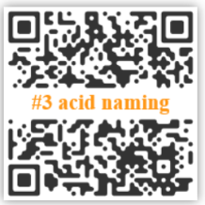
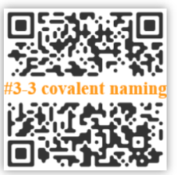
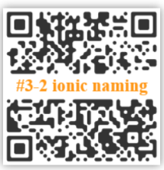
#3: To translate names of chemicals into formulas you must know how a substance is bonding. The type of bond will identify the procedure used to name the substance. Whether that be ionic, covalent, or acidic.

- Convert the following names to formulas and vice versa.
- Hydronitric acid = ___________________ NH₄NO₃ = _________________________
- Aluminum chloride = _________________ CaCl₂ = ___________________________
- Sulfur trioxide = _____________________ BF₃ = _____________________________
- Copper (II) sulfate = __________________ H₂SO₃(aq) = ________________________
- Nitrous Acid = _______________________ HF(aq) = ___________________________
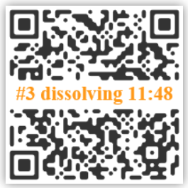
#3 Particulate representation of ions in solutions. Go to time 11:48 on video.
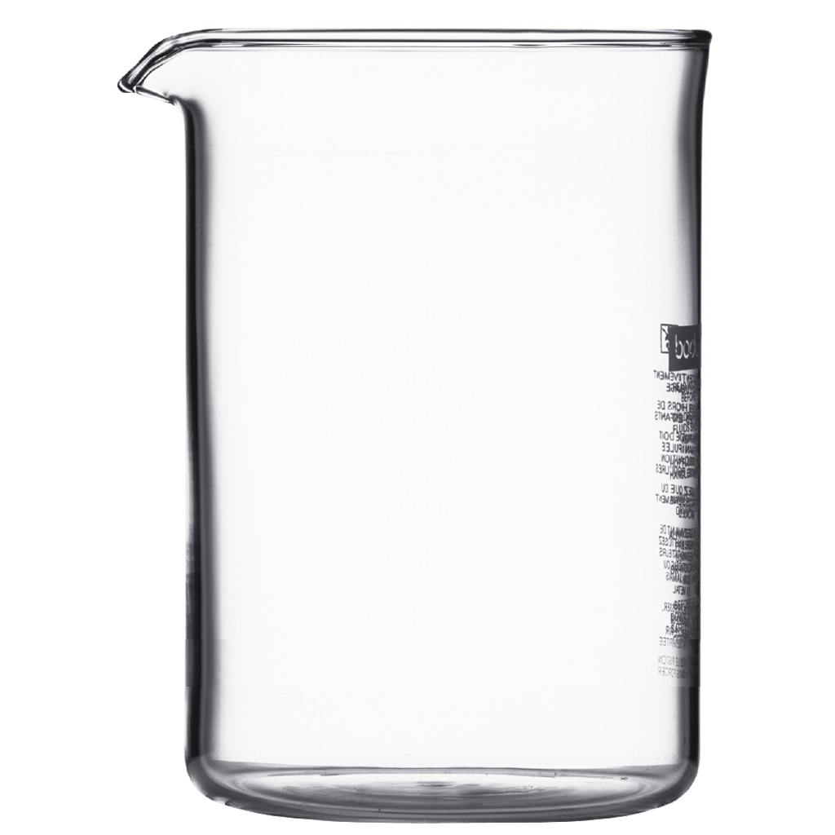
- In the beaker below draw a particulate model of the following two equal concentration solutions. CuCl₂ and NaOH

#5-7: Solubility based chemical reactions
- 0.2M Sodium sulfate is poured into 0.2M lead (II) nitrate solution. Translate and determine the products of the reaction.

- Draw both beakers proportionally and the products proportionally in the 3 beakers provided.

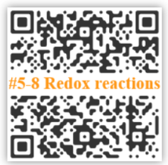
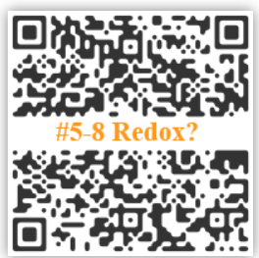
#5-8: Oxidation Reactions.
- With the following two reactions indicate if the reaction is an oxidation reduction reaction and if so, who is being oxidized and reduced.

- HCl + NaOH → NaCl + H₂O

- Al + Cu(NO₃)₂ → Al(NO₃)₃ + Cu

- For any reaction above that is a redox reaction, write out the half reactions, calculate the resulting voltage, write the balanced reaction and list any spectators.

- Draw out a particulate diagram of the redox reaction.

- Copper when dropped into HCl does not cause a reaction. Justify this with calculations.

